PURPOSE

The purpose of race waypoints is threefold:
- Constrain route choice
- Show race progression
- Gate as a skill component

Features

We need a visual representation of waypoints and the finish line in the game. It will accurately represent a trigger volume that you must pass through. We need four art objects:
- 10 meter-wide finish line
- 20 meter-wide finish line
- 10 meter-wide waypoint
- 20 meter-wide waypoint

Waypoint Arch

The waypoints can be rectangular in shape, something like the ones in Midtown Madness:

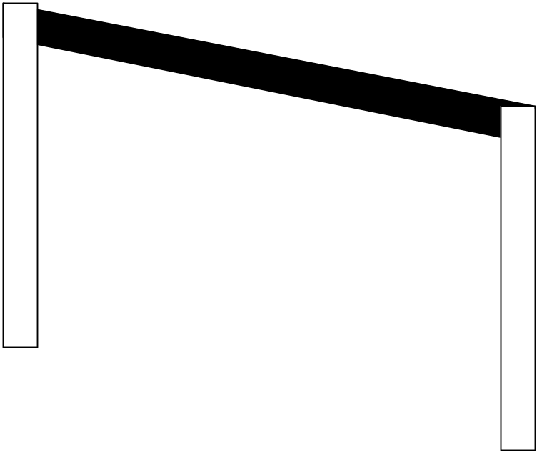

Finish Line Arch

The finish line will be similar in appearance to the Waypoint arch but should feature a “finish line” banner and checkered tile area on the track.

Start Line Arch

The start line will be similar in appearance to the Waypoint arch but should feature a “STARTING LINE” banner and checkered tile area on the track.

